Signs of Santa

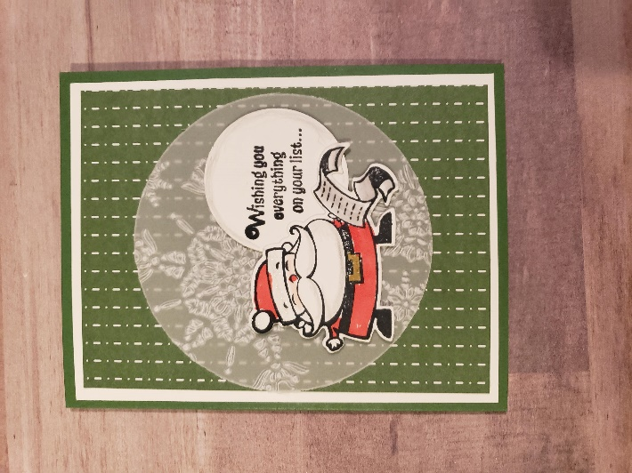

Measurements:
- Card base cut at 8-1/2 x 5-1/2 and scored at 4-1/4 (Green)
- Basic White CS:
  - 4 x 5-1/4
  - 4-1/4 x 5-1/2 (for stamping images and die cutting)
  - 4 x 2-3/4 (inside of card
- DSP:
  - 3-3/4 x 5
  - 4 x 1-1/2 (inside of card)
- Vellum measured 3-5/8” circle

Instructions:
- Fold card base
- Attach 4 x 5-1/4 piece of Basic White CS to card base
- Attach large piece of DSP to card base
- Stamp images on leftover large piece of Basic White CS and color images
- Die cut stamped images
- Using 1-3/4 circle punch, stamp saying and punch out
- Emboss vellum circle with Northern Flurry EF
- Place Santa and circle saying on vellum using dimensionals
- Place entire piece on card base
- Inside of card
  - Place DSP on Basic White CS
  - Attach to inside of card on only 3 sides, leaving top open to insert gift card
  - Stamp sentiment on small Basic White strip and trim to appropriate length
  - Place elf and sentiment on DSP using dimensionals

Signs of Santa 3-D Project

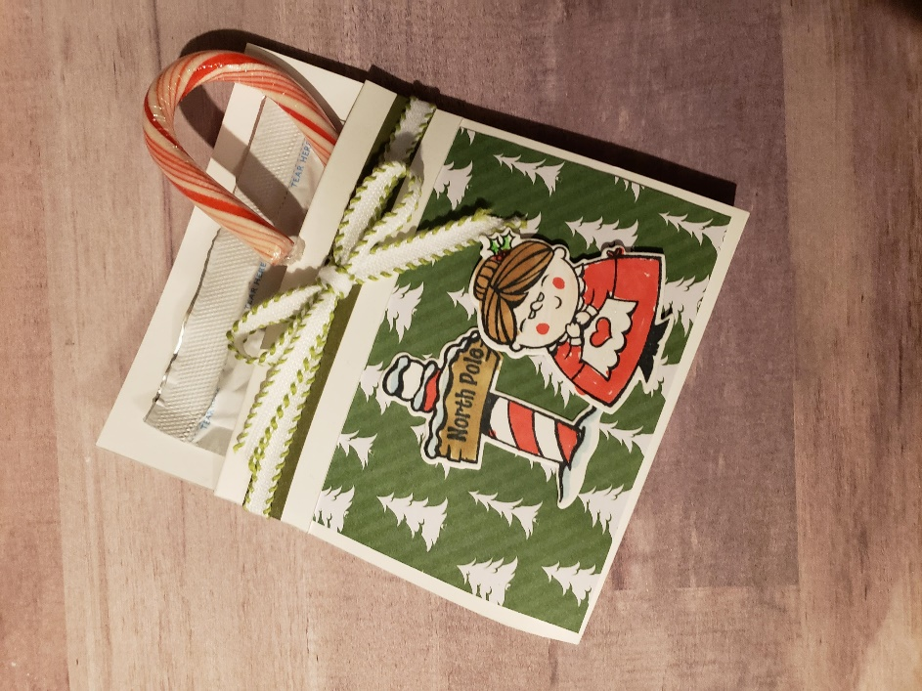

Measurements:
- Basic White pocket
  - 4-1/4 x 10-1/4
  - Score at 5, 5-1/2 and 9-1/4
- DSP
  - 4 x 3

Instructions:
- Fold on score lines, folding 9-1/4 score towards front of pocket
- Attach DSP to front of pocket
- Adhere top scored flap with DSP tucked underneath
- Attach stamped images using dimensionals on Mrs. Claus
- Wrap washi tape along entire card to create pocket
- Attach ribbon around card

